SUMMER ACADEMY REPORT

Euracademy Association’s 15th Summer Academy

“Social Economy and Sustainable Rural Development”

Mouzaki, Karditsa, Greece,

16th to 23rd July 2016

CO-ORGANISERS
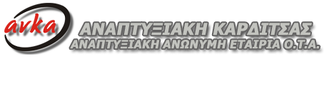

1. Day 1 - Social Economy and Sustainable Rural Development. The role of social enterprises and cooperatives in the economy of rural areas
Following the welcome by representatives of the co-organisers, i.e Fouli Papageorgiou, President of Euracademy Association, Fotios Alexakos, Chairman of ANKA – Development Agency of Karditsa, Mayor of Karditsa, and Olga Drossou, Director of Heinrich Böll Foundation Greece, and greetings by Giorgos Kotsos, Mayor of Mouzaki, Fouli Papageorgiou presented Euracademy Association, its integrated approach towards Rural Development, the Association’s activities and the methodology supporting the Euracademy Summer Academies.
The first Speaker, Márta Márczis, President of the European Association for Information on Local Development – AEIDL, introduced the theme of social economy in relation to sustainable rural development and shared some of her dilemmas with the audience. What is the future of the rural Europe and how its economy can be supported by social enterprises? Are the social enterprises really about ‘contributing to the rural economy’, or do we agree that this is something else? Does the social entrepreneurship focus on creating social capital and ‘making the world, including rural areas a better place’?
The workshop group sessions that followed, took to questions posed by the speaker, concerning the wider context of the rural-social-economic development in Europe today, the availability of the necessary mentality and skills to develop the social economy in rural areas, and basic approaches to the development of a sustainable rural economy through social enterprises.
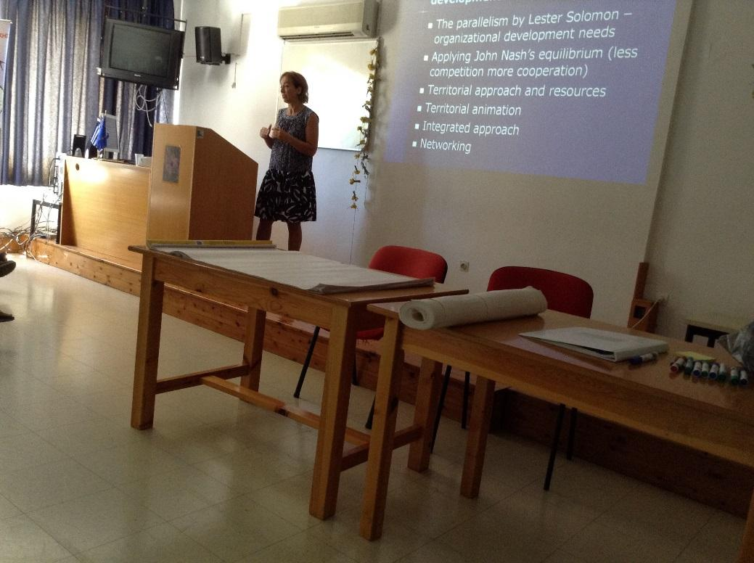

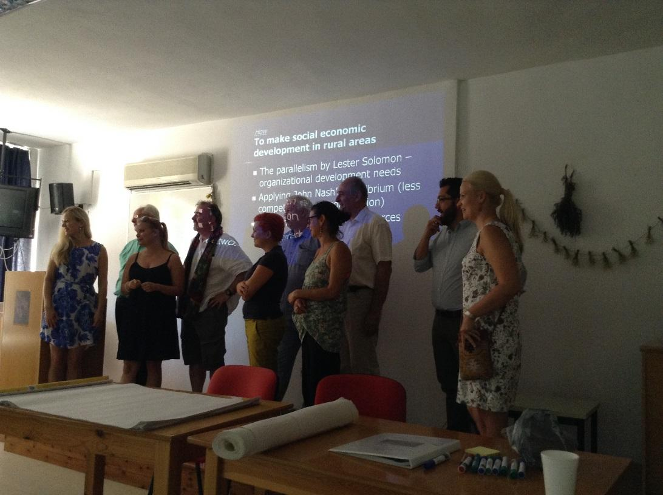

Panel 1. Definition and historical development of social enterprises and cooperatives in Europe
Dr Roger Evans, business and education consultant, Secretary General of Euracademy, took to defining social enterprises across Europe, their 3 main characteristics (explicit social aims, commercial activity, social ownership), and two aims of equal importance: a commercial aim and an explicit social and/or environmental aim.
Michael Kuegler, Board member of the European Forum of Rural Advisory Services, talked about opportunities in empowering advisory services and knowledge transfer by good policy design and governance of AKIS (agriculture knowledge and innovation system), as well as support for specific actors (advisors, farmers, networks). He also introduced EUFRAS (European Forum for Agricultural and Rural Advisory Services) as a good example of cross border learning.
The workshop group sessions that followed, took to questions posed by the Panel, regarding ways that local and cross-border networking can support the creation of rural social enterprises and cooperatives, the pros and cons of imposing a legal definition of social enterprises, and the kind of support and tools needed for growing the social economy. The topic that dominated the discussion that followed, was the definition of social enterprise in different European countries, depending on the historical context and the overall business mentality. The outcome was that definitions differ, being either stricter and legally binding like in the case of Greece, or more flexible and including like in the case of the UK.

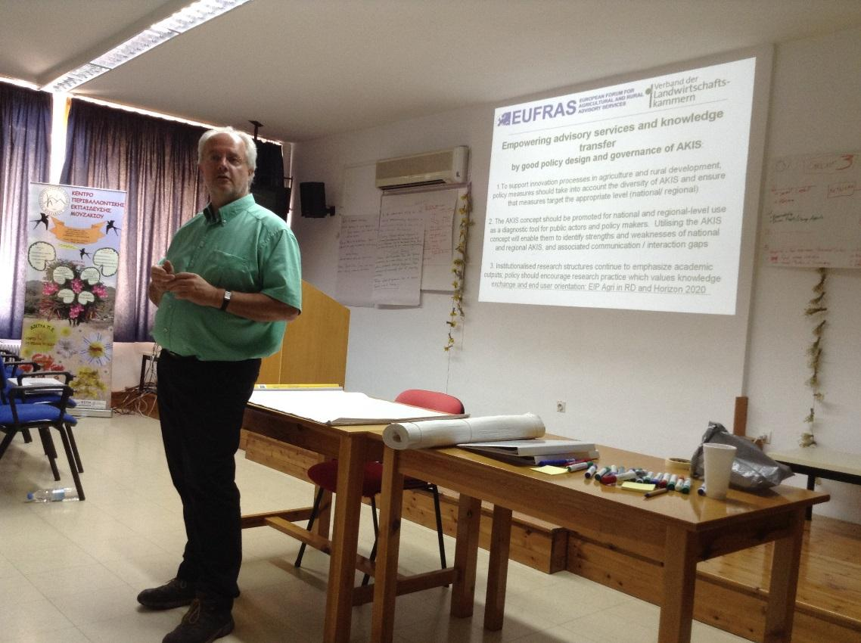

2. DAY 2 - Social economy and social innovation in rural areas
Panel 2. How social enterprises put social innovation to practice?
Dr Artur Steiner, Lecturer in Social Entrepreneurship, Yunus Centre for Social Business and Health, Glasgow School for Business and Society, addressed the issue of local collectives participating in culture change to provide their own services, representing potential for social innovation. The case study he presented, the Older People for Older People (O4O) project, aimed to address mismatch between the expectations and lived realities of older people in remote rural communities. Through this case study, he highlighted the role of social enterprises in introducing social innovation and addressing challenges of ageing population.
Sofia Adam, Researcher, touched on the terminological ambiguity and ideological pluralism of social economy and social enterprises mainly presenting the views of the anglosaxon and the continental traditions, whether social economy could bring forward an economic reconstruction or transformation, and finally opportunities and challenges that lie ahead.
The workshop group sessions that followed, took to questions posed by the Panel, regarding ways that social enterprises could introduce social innovation in the participants’ localities by combining challenges to create a solution, as well as in which ways are social enterprises different than offering the set services through the private or public sectors, and what kind of support should be expected from the public sector. Again the discussion that followed was concentrated on defining those characteristics and productive relationships that make social enterprises different in relation to the private and public sectors, and in what ways these characteristics can ensure their sustainability.

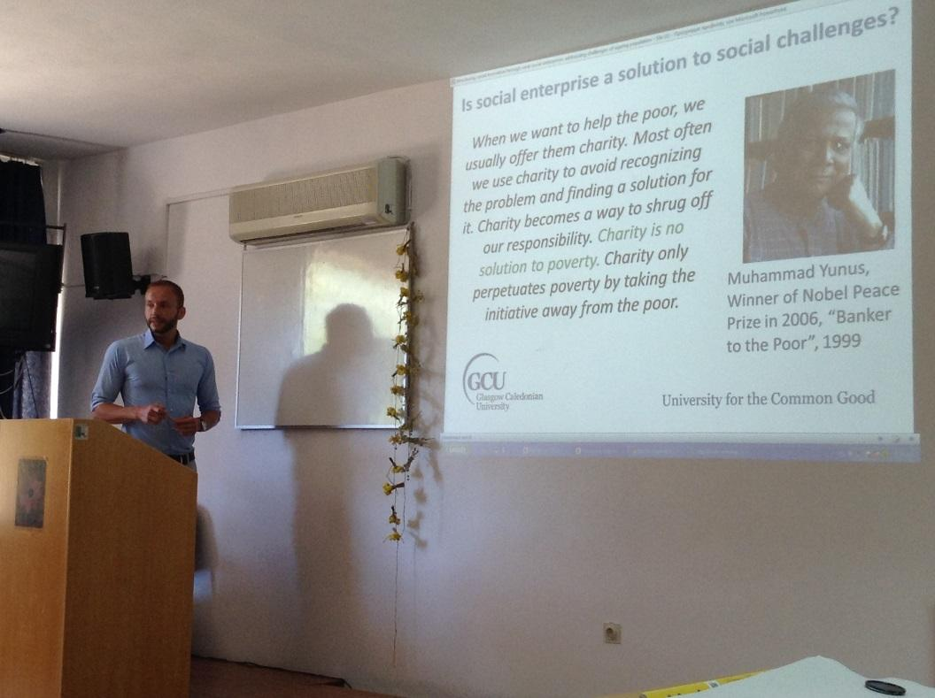

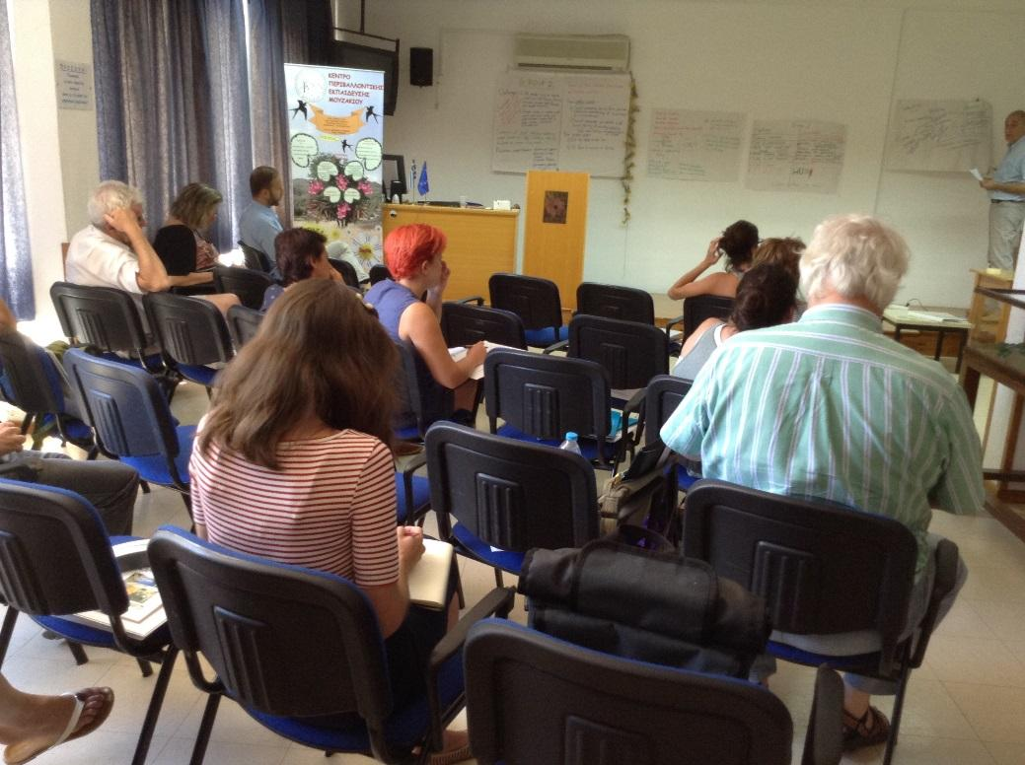
Panel 3. The role of social enterprises in integrating or re-integrating people in the world of work, including disadvantaged people
Patricia Honvari, Researcher, Hungarian Academy of Sciences, introduced the topic of the social cooperatives and took on questions like how do these cooperatives function, what are their main tasks, what results can they show up, what does the establishment of a social cooperative in rural areas mean, what is the case with the financing and what happens with the profit, and what factors can lead the social cooperatives to a dead end. In order to demonstrate the points made, the presentations was focused on Hungarian best practice examples.
Popi Sourmaidou, Ergani – Center for the Support of Employment and Entrepreneurship of Women, presented the issue of women participation in social economy especially in rural areas, focusing on gender equality issues in rural areas, analysing the characteristics of women involvement in social economy and drawing on good practice examples of women cooperatives all over Greece.
The workshop groups sessions that followed, took to questions posed by the Panel, regarding good practice examples of social cooperatives from the participants’ own countries, the potential of social cooperatives in different sectors (agricultural, heritage-cultural, sales etc.), ways to avoid threats and challenges they face, and the contribution of social innovation to their development.

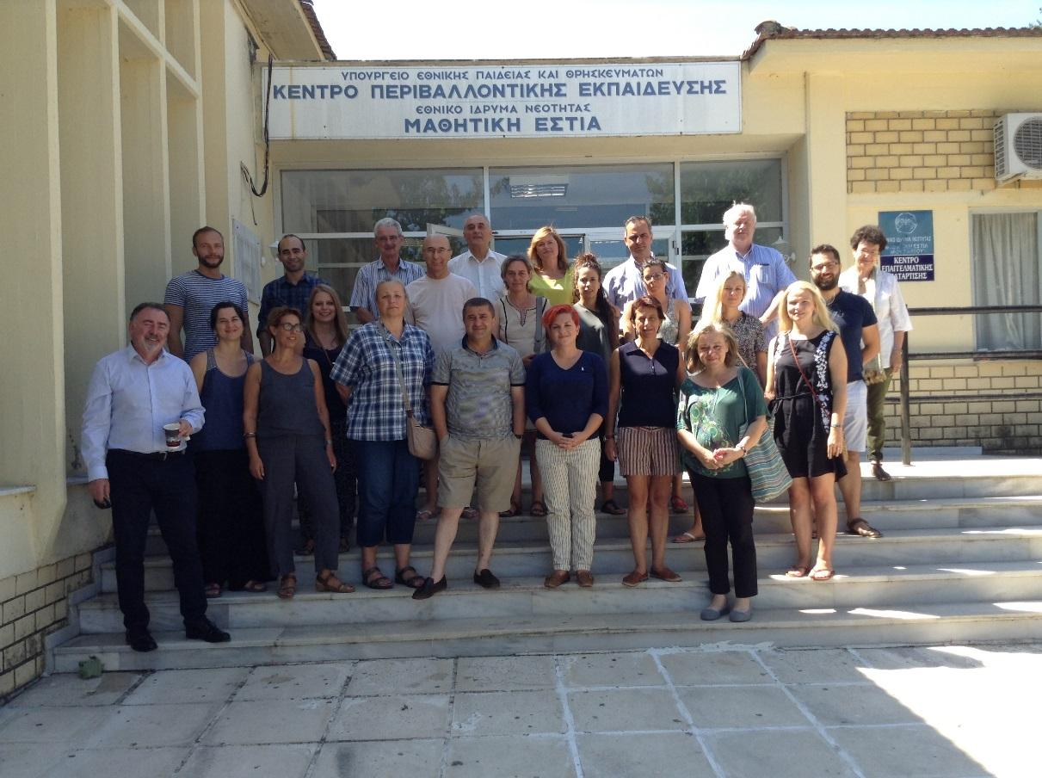

3. DAY 3 - Support systems for social enterprises
Panel 4. Supporting the social enterprises’ development process and operation
Stephen Clare, Director at CYTA Consulting, focused on place-based enterprises, community-owned and managed, accountable to the local community and often driven by a social justice agenda, largely operating in areas of market failure, where the state and the private sector have struggled. The speaker highlighted the importance of peer networking – whether collectively or through one-to-one discussions, talking to people ‘just like you’ who have ‘been there, done that, got the t-shirt’, as an efficient support mechanism to tackle the challenges that the community enterprise model brings, e.g. how to incorporate accountability mechanisms into governance systems, how to manage conflicts and/or agree priorities, how to build business and management skills and capacity, accessing finance etc.
Vasilis Bellis, CEO of ANKA – Development Agency of Karditsa, presented the idea of an Eco-system of Social Enterprises, as different from a simple group of SEs. The main differences are that the members of an ecosystem establish an internal system of relations, they share common vision, strategy and values, they attempt to develop common services and succeed “economies of scale”. The speaker went on to address questions like how an ecosystem is established starting from scratch, which is the role and the priorities of a “supporting mechanism”, which are the key “common services” to be developed, and how the social enterprises of Karditsa try to set up their “ecosystem. The story of the local ecosystem of Karditsa started in the 90s and was accelerated in the era of the economic crisis in Greece. Nowadays all types of social enterprises (mainly co-operatives) are parts of it.
Sophie Lamprou, co-founder and Strategy Director of the Impact Hub Athens, presented the Impact Hub as an alternative support mechanism of social enterprises, focusing on its philosophy for supporting ideas that will “change the world”, it’s global reach and network, and the way it operates and offers much needed services to social enterprises.
The workshop groups sessions that followed, took to a comparative analysis between the support mechanisms presented by the Panel, i.e. the peer networking between community enterprises, the ecosystem of social enterprises, and the Impact Hub model. During the discussion that followed, a conclusive point was that the impact hub mechanism could very effectively play the role of the support mechanism in an ecosystem of social enterprises.
Following the discussion, there was an online presentation by Jaan Aps, Estonian Social Enterprise Network, presenting the Estonian Social Enterprise Network, its aims in supporting social enterprises in Estonia, and its approach in developing a common standardised framework for all social enterprises to follow: A „Social Enterprise Company Registry“– standardised principles and tools to analyse and insert relevant data – that feeds into „Social Enterprise LinkedIn“ – a standardised environment for publishing SE data (that enables „search“, „compare“, and statistics). The framework’s ambition is to help measure the social enterprises’ performance and determine their value.
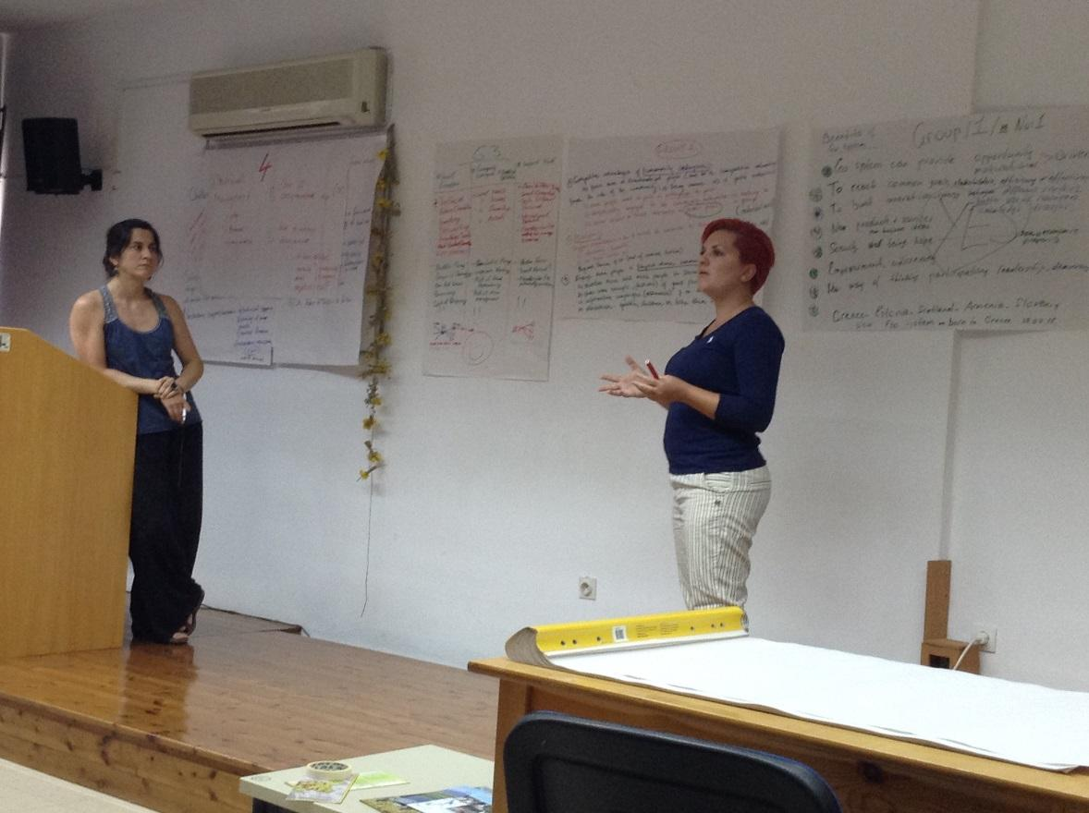

Panel 5. Best practice examples on support systems
Ryan Howard, CEO at South and East Cork Area Development – SECAD, introduced the audience to the long history of social economy in Ireland and the importance of the social economy and the role that Local Development Companies have played in developing this sector. The speaker focused on the challenges of developing social enterprise in Ireland referencing research material on this matter developed from an EU Perspective, a National Review recently launched by the Network of Local Development Groups in Ireland (Irish Local Development Network) and a research report generated by SECAD into the level of social enterprise (and their needs) in their local region.
Dr Tasos Vasiliadis, President of the Institute of Entrepreneurship, focused on the development of the professional profile of the advisor/educator of social economy, proposing an innovative method of certification of non-formal learning that responds to the European Union directional guidelines in relation to the recognition of learning outcomes. The speaker went on to present the research effort, compiled after literature desk research and the use of the Delphi method in three European countries, proposing the Professional Profile of the advisor/educator of social economy, which consists of six (6) Main Tasks, which the advisor/educator must be able to perform. The proposed method of certification of learning outcomes, includes three categories, 1) the valuation of the candidates’ CV, 2) the conduct of an on-line test of multiple choice questions and 3) the preparation of a case study.
In the plenary discussion that followed, on the effectiveness of different support systems at a local level, a conclusive point was that the effectiveness depends on the local circumstances and the implementation of the support model itself.

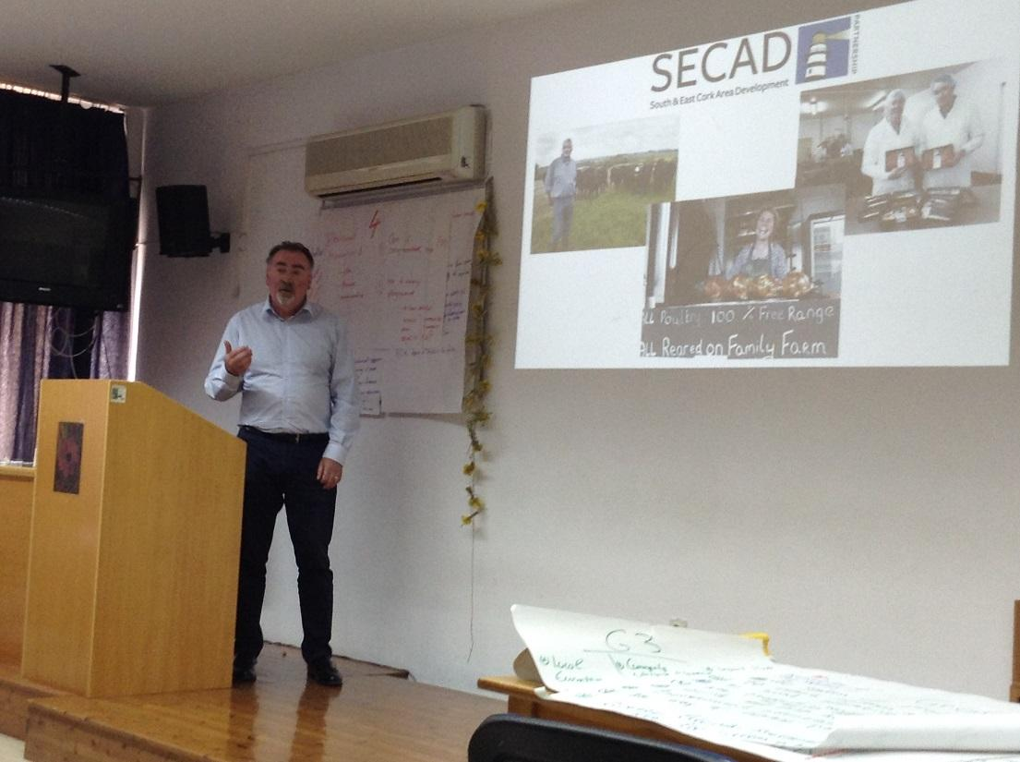

4. Day 4 & Day 5 – Stydy Trips
The participants were divided into 3 groups, and each group visited a different set of local social enterprises and cooperatives.
Group A visited the factory of the Energy Cooperative of Karditsa, the social enterprise "taste from village" (Kedros), the Network of Food and Drink (Chamber of Karditsa), the Agricultural coop of cow and sheep breeders (Lazarina), the Suppliers coop of Agronomists of Karditsa, the Agricultural coop Efkarpon (Mataraga), and the Lactimed- Kissas Dairy at Mouzaki.
Group B visited the social enterprise Romvos (Κobelos), the Agricultural coop Stevia (Κobelos), the Cooperative Bank of Karditsa, the social enterprise Ilakati, the agricultural coop of snail producers, the agricultural coop of tomato growers THESTO, the milk coop of Thessaly THESGALA, and the Cereals et al cooperative of Thessaly THESGI.
Group C visited the agricultural coop of pulse growers (Hub of ANKA), the local Women's Centre, the Mountaineering Club ΕΟSΚ and other voluntary societies, the Pafsilipon Ltd Municipal Enterprise, the social enterprise “Garden creations”, the Cooperative Bank of Thessaly (Trikala) and the Volunteers association of Trikala.

5. Day 6 – Study Trips Reports
The Study Trips Groups worked on their presentations drawing on issues they faced during the study visits during the previous 2 days.
All 3 Groups presented their study trip reports in the form of mini theatrical plays, where each group member was given a role. Group A focused on the issue of the social enterprise definition and whether some key enterprises and coops that they visited fell within the definition previously discussed during the 3 first Summer Academy Days. Group B focused on the issue of what sparks up the creation of a social enterprise or coop in the time of the economic crisis and what are the crucial first steps in building it. Group C focused on 3 main mentalities towards social enterprises and coops, i.e. the mentality that opposes the social enterprise philosophy, supporting mainly traditional models and the family business, the liberal mentality that strongly supports the social economy philosophy, and the mentality in between the previous 2 that supports the social economy but feels there is a need for more research, tests and regulations.
There were also presentations of good practice case studies, by:
- Lili Mahne, Development Centre of the Heart of Slovenia
- Theodoros Aleksandrou, Institute of Business Development
- Zorair Kirakosian, American University of Armenia
- Triin Lääne, Tartu Rural Development Association, ELARD
Finally, the participants were encouraged to evaluate the Summer Academy in terms of features they enjoyed most and room for improvement.

